The 31st KKHTCNN Symposium
on
Civil Engineering​

22-24 November 2018

Campus Plaza Kyoto, Kyoto, Japan

Organized by Kyoto University

CONTENT
Coordinators 1
CONFERENCE VENUE 2
Technical Visit and Cultural Tour 7
1. Yodogawa Bridge Construction of Shin-Meishin Highway 7
2. Redevelopment Project of Amagase Dam 7
3. BYODOIN Temple: World Heritage 8
ACCOMMODATIONS 9
GENERAL INFORMATION 10
Transportation Information 10
Registration 11
Weather and Temperature 11
Emergency Contact 11

Coordinators

KAIST: Prof. Gye-Chun Cho
HKUST: Prof. Xueqing Zhang
TU: Prof. Huanjun Jiang
CU: Prof. Tirawat Boonyatee
NTU: Prof. Louis Ge
NUS: Prof. Sze Dai Pang
KU: Prof. Kunitomo Sugiura

CONFERENCE VENUE

- Campus Plaza Kyoto
Address: Campus Plaza Kyoto
Nishino-Toin-dori Shiokoji Sagaru, Shimogyo-ku,
Kyoto 600-8216, Japan
Tel： +81-75-353-910
Access: http://www.consortium.or.jp/about-cp-kyoto/access

Note: How to reach the Campus Plaza Kyoto
- Campus Plaza Kyoto is located in front of Kyoto JR station and just in front of APA Hotel in Ekimae.
- Please take the north exit at Kyoto JR station. You will see the bus platform if you orient to north. Please walk to west. It takes approx. 2 min.

- Welcome Dinner: Public House
Address: Public House
402 Mongakucho, Shimogyo-ku, Kyoto 600-8222, Japan.
Tel： +81-75-708-5038
Access: https://www.worldheritage.co.jp/publichouse/access

- Conference Banquet: Kyoto Tower Hotel
Address: Kyoto Tower Hotel
721-1 Higashishiokoji-cho, Shichijo-sagaru Karasuma-dori,
Shimogyo-ku, Kyoto 600-8216, Japan
Tel： +81-75-361-3215
Access: https://www.keihanhotels-resorts.co.jp/tower_hotel/en/access.html

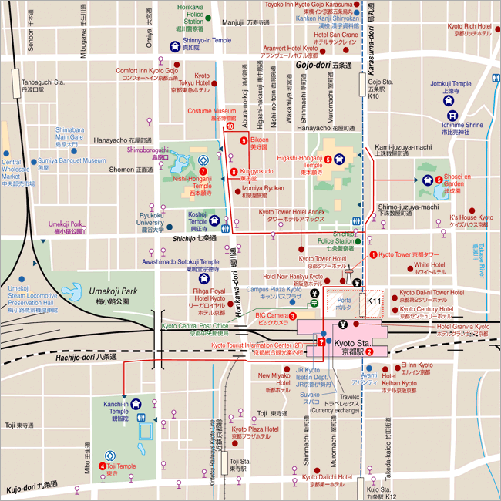
KKHTCNN
Venue
Access to KKHTCNN venue, Campus Plaza Kyoto

Floor Plan Layout
The conference will take place at 4th and 5th floor of Campus Plaza Kyoto.
The floor plan layout for Day 1:
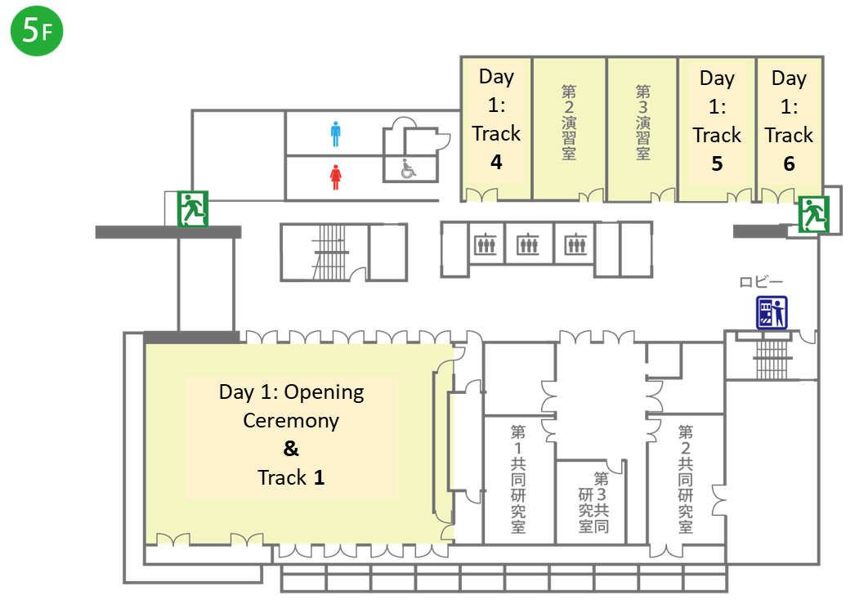
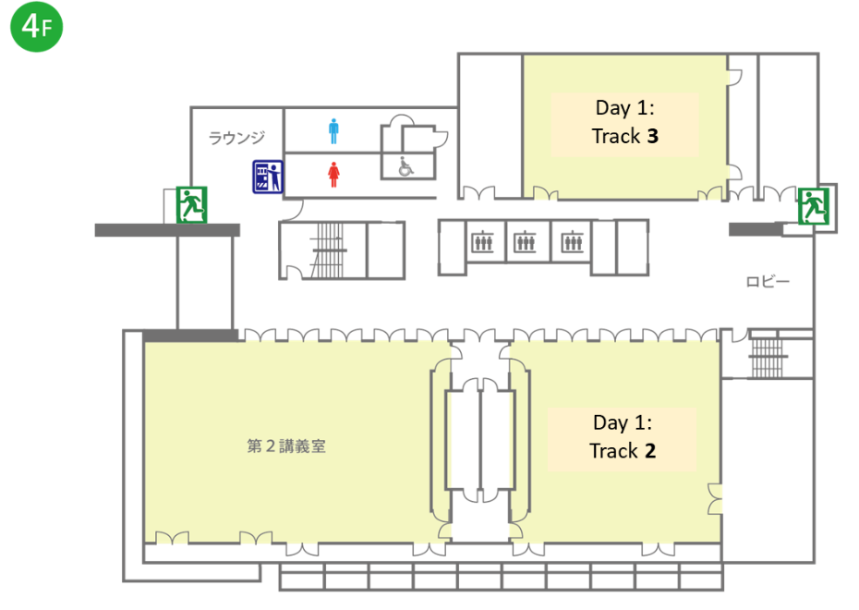

The floor plan layout for Day 2:
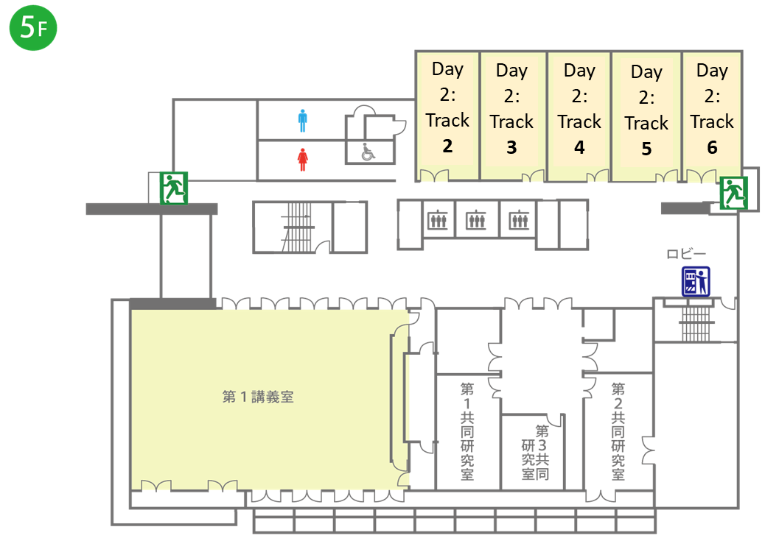
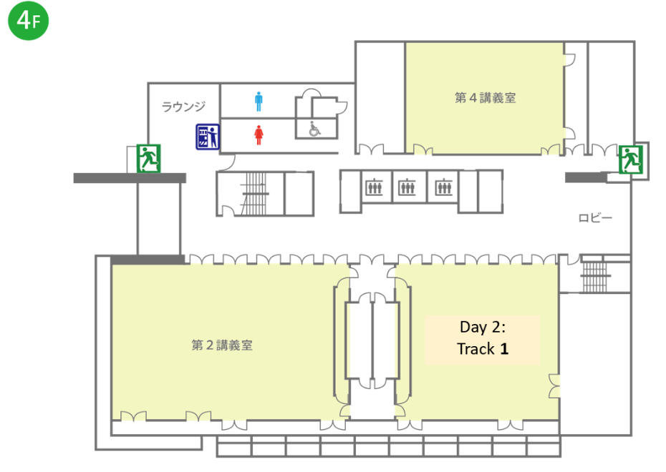

Technical Visit and Cultural Tour
- November 2018, Kyoto, Japan

JOYO Viaduct Construction of Shin-Meishin Highway

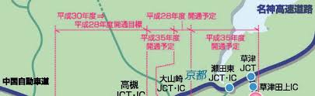
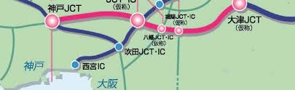
Maps of Yodogawa bridge construction of Shin-Meishin highway

Amagase Dam

The Amagase Dam (天ヶ瀬ダム) is an arch dam on the Uji River just upstream from Uji City in Kyoto Prefecture, Japan. The main purpose of the dam is flood control but it supports a hydroelectric power station and creates the lower reservoir for the Kisenyama Pumped Storage Plant. The dam itself serves a 92 MW power station while the pumped-storage power station upstream has a 466 MW capacity. Construction on the dam began in 1955 and it was complete in 1964. The pumped-storage power station became operational in 1970. Both plants are owned by Kansai Electric Power Company.
The dam is a 73 m (240 ft) tall, 254 m (833 ft) long variable-radius arch type with structural volume of 162,000 m3 (5,720,976 cu ft). The dam withholds a reservoir called Lake Hōō (鳳凰湖 Hōō-ko, lit. "Lake Phoenix") of 26,280,000 m3 (21,306 acre⋅ft) of which 20,000,000 m3 (16,214 acre⋅ft) is active or "useful" storage. It has a surface area of 1.9 km2 (1 sq mi).
The dam's spillway consists of four 4.36 m (14 ft) x 10 m (33 ft) floodgates on its crest with a maximum discharge capacity of 680 m3/s (24,014 cu ft/s). In the middle of the dam body, there are three 3.6 m (12 ft) x 4.7 m (15 ft) gate-controlled orifice openings with a maximum discharge of 1,110 m3/s (39,199 cu ft/s). The dam's power station has a 92 MW installed capacity and a discharge capacity of 186 m3/s (6,569 cu ft/s).

BYODOIN Temple: World Heritage

Byodoin Temple (平等院, Byōdōin) is a striking example of Buddhist Pure Land (Jodo) architecture. Together with its garden, the temple represents the Pure Land Paradise and was influential on later temple construction. Byodoin was initially built in 998 as a countryside retreat villa for the powerful politician Fujiwara no Michinaga, not as a temple.
Michinaga's son turned Byodoin into a temple and ordered the construction of its most spectacular feature, the Phoenix Hall. Although the building was given another official name, almost immediately after its construction in 1053, it was nicknamed Hoodo ("Phoenix Hall") because of its shape and the two phoenix statues on its roof. The hall is now featured on the back of the Japanese ten yen coin.
Byodoin's buildings were repeatedly lost to fires and other calamities over the centuries, however, the Phoenix Hall was never destroyed, making it one of the few original wooden structures to survive from the Heian Period. Visitors to Byodoin can enter the Phoenix Hall on short guided tours (in Japanese) that start every 20 minutes and cost an additional 300 yen. It houses a statue of the Amida Buddha.
Byodoin's unique treasure house is constructed mostly underground to not distract from the Phoenix Hall. It exhibits an assortment of the temple's most valuable artifacts, including dozens of designated important cultural properties and national treasures. The treasure house also contains informative, multilingual displays on Byodoin's construction and history.
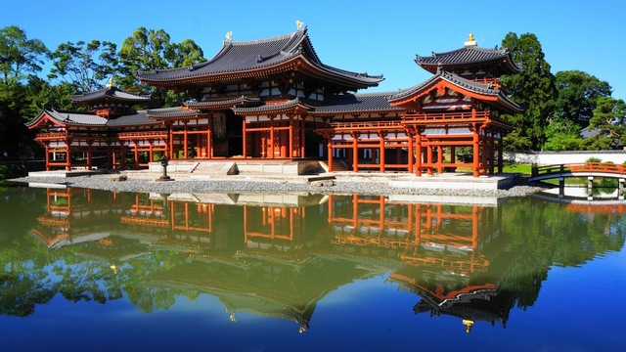
The temple grounds

ACCOMMODATIONS
Many hotels are available around the station and in the downtown area of Kyoto. These areas are connected by the subway, buses and taxies. Furthermore, the symposium venue is located by 5 minutes’ walk from Kyoto Station.
Kyoto station is easily accessible from Shin Osaka Station and Osaka Station. The participants also can consider Osaka City as place for the accommodation. We recommend that participants secure the accommodations as early as possible because November is peak month in Japan.
Access to Kyoto Station from Shin-Osaka Station and Osaka Station
The best way to travel from Shin Osaka and Osaka Station to Kyoto Station is by the Special Rapid service train on the JR Kyoto Line.
- Shin-Osaka Station → Kyoto Station (24 minutes for JPY 560)
- Osaka Station → Kyoto Station (29 minutes for JPY 560)
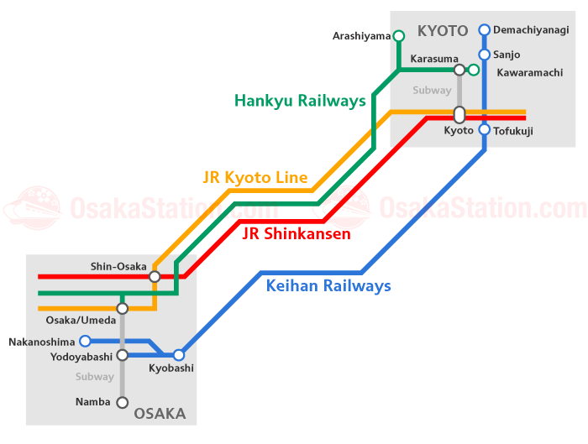
The map of JR Kyoto Line connected Shin-Osaka Station, Osaka Station and Kyoto Station
Another city to be consider is Otsu City. Otsu is the capital city of Shiga Prefecture. There are a number of sites of interest in Shiga Prefecture such as Lake Biwa, the largest freshwater lake in Japan.
Access to Kyoto Station from Otsu Station
The best way to travel from Otsu Station to Kyoto Station is by the JR Tokaido-Sanyo Line.
- Otsu Station → Kyoto Station (9 minutes for JPY 200)

GENERAL INFORMATION

Transportation Information
Japan has three main international airports. The nearest airport from Kyoto is Kansai International Airport (KIX, Osaka). So, we recommend you to arrive at Kansai International Airport.
Access to Kyoto Station from Kansai International Airport
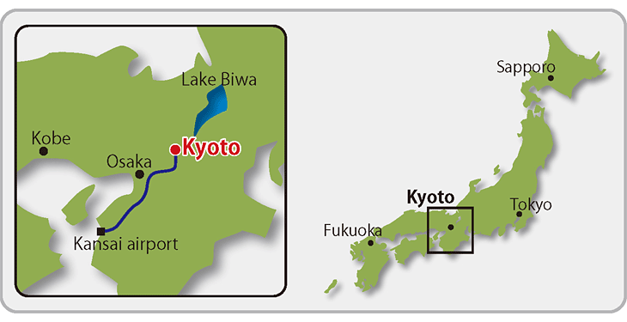
1. Train
- Airport Limited Express Train “Haruka”
One-way fare ： ¥2,850 (non-reserved seat) ¥3,170 (reserved seat)
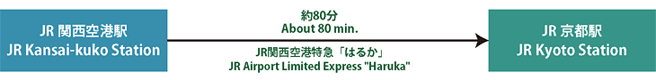
Kansai International Airport Train Access Information:
https://www.kansai-airport.or.jp/en/access/train/
- JR Train
One-way fare ： ¥1,880(Transfer Once)
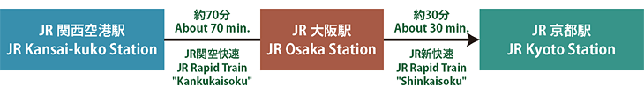
2. Airport Limousine Bus
One-way fare ： ¥2,550
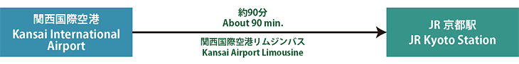

Airport Limousine Bus Time Table:
http://www.kate.co.jp/en/timetable/index

3. Shuttle Taxi (by advance reservation only 2 days before trip through their website)
- YASAKA Kanku Shuttle Taxi
  - http://www.yasaka.jp/english/

- MK Skay Gate Shuttle Taxi
  - https://www.mktaxi-japan.com/kyotoshuttle-m

Registration
The registration desk will be open in 2nd floor of Campus Plaza Kyoto. The registration will start from 9:00 am on 22 November 2018. The registration fees are as follow:
 | Registration fee
Staff | JPY 40,000
Student | JPY 20,000

It should be notice that only cash is acceptable. Lunch, refreshments, reception, banquet, conference bag, conference gift and technical tour are all included in the registration fees.

Weather and Temperature
The weather in Kyoto in November is around 10 to 20 degrees and it is the end of fall seasons.

Emergency Contact
119 is the direct-dial free phone number for non-criminal emergencies in Japan.
How to use the 119 emergency number
1. Dial 119 on any phone.
*The call is free of charge from public and mobile phones.
2. Clearly describe what has happened.
3. Tell the location and, if possible, the address of the place where the emergency happen.

